Create a simple cloud software application for Students Attendance System using any Cloud Service Provider to demonstrate SaaS include the necessary fields such as name of the students, course, present , Absent, course attendance, OD request, grade, attendance percentage, etc.

Step1: Creating a software Application for student attendance system through online cloud service.

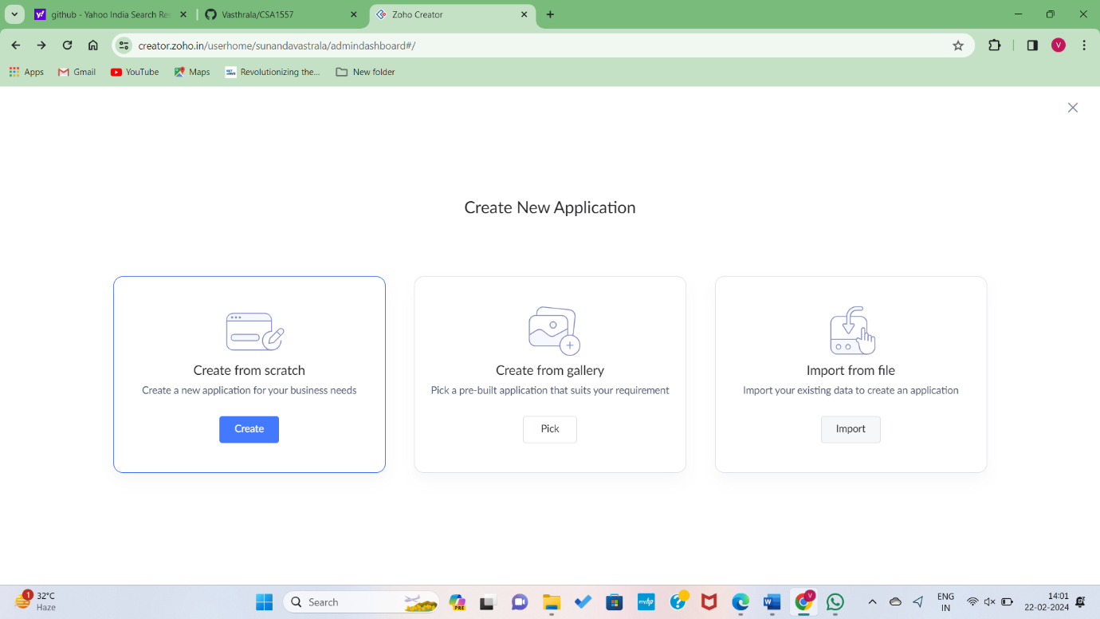

Step2: Creating a new form to do application for student attendance system.

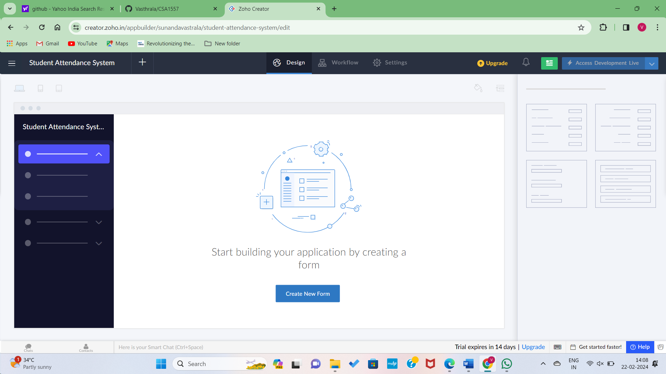

Step3: Setting Up Cloud Services to the application form regarding student attendance system.

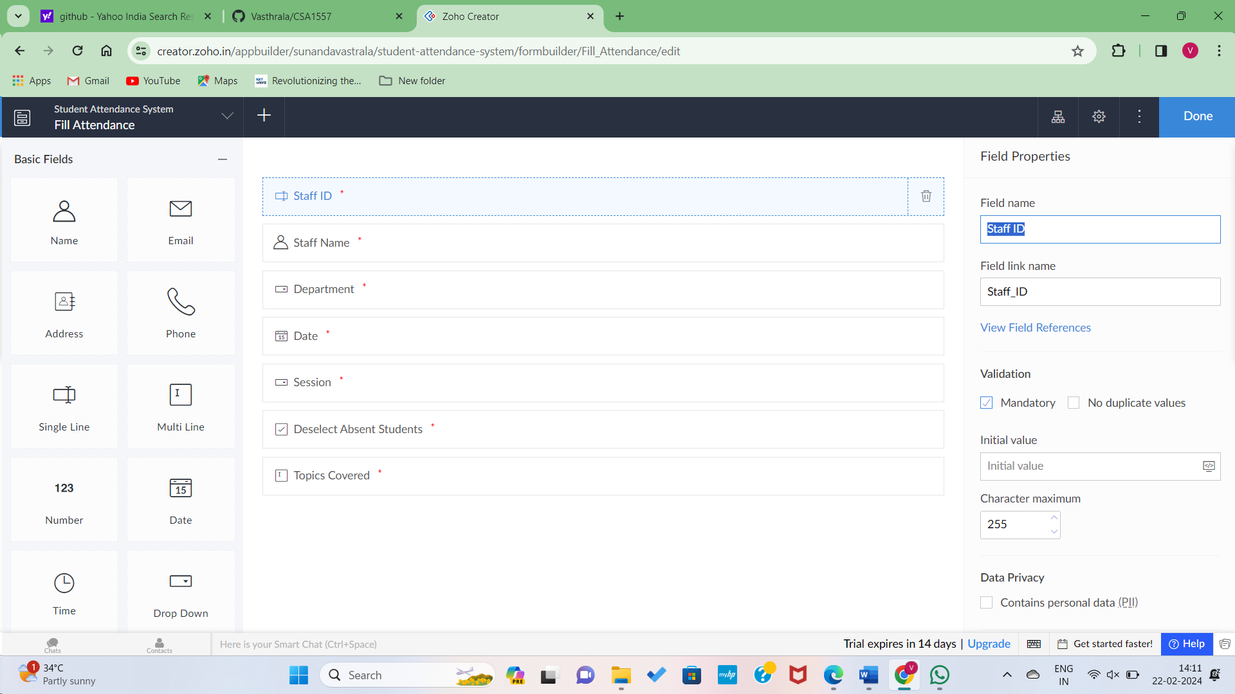

Step4: Data Entering to the application form.

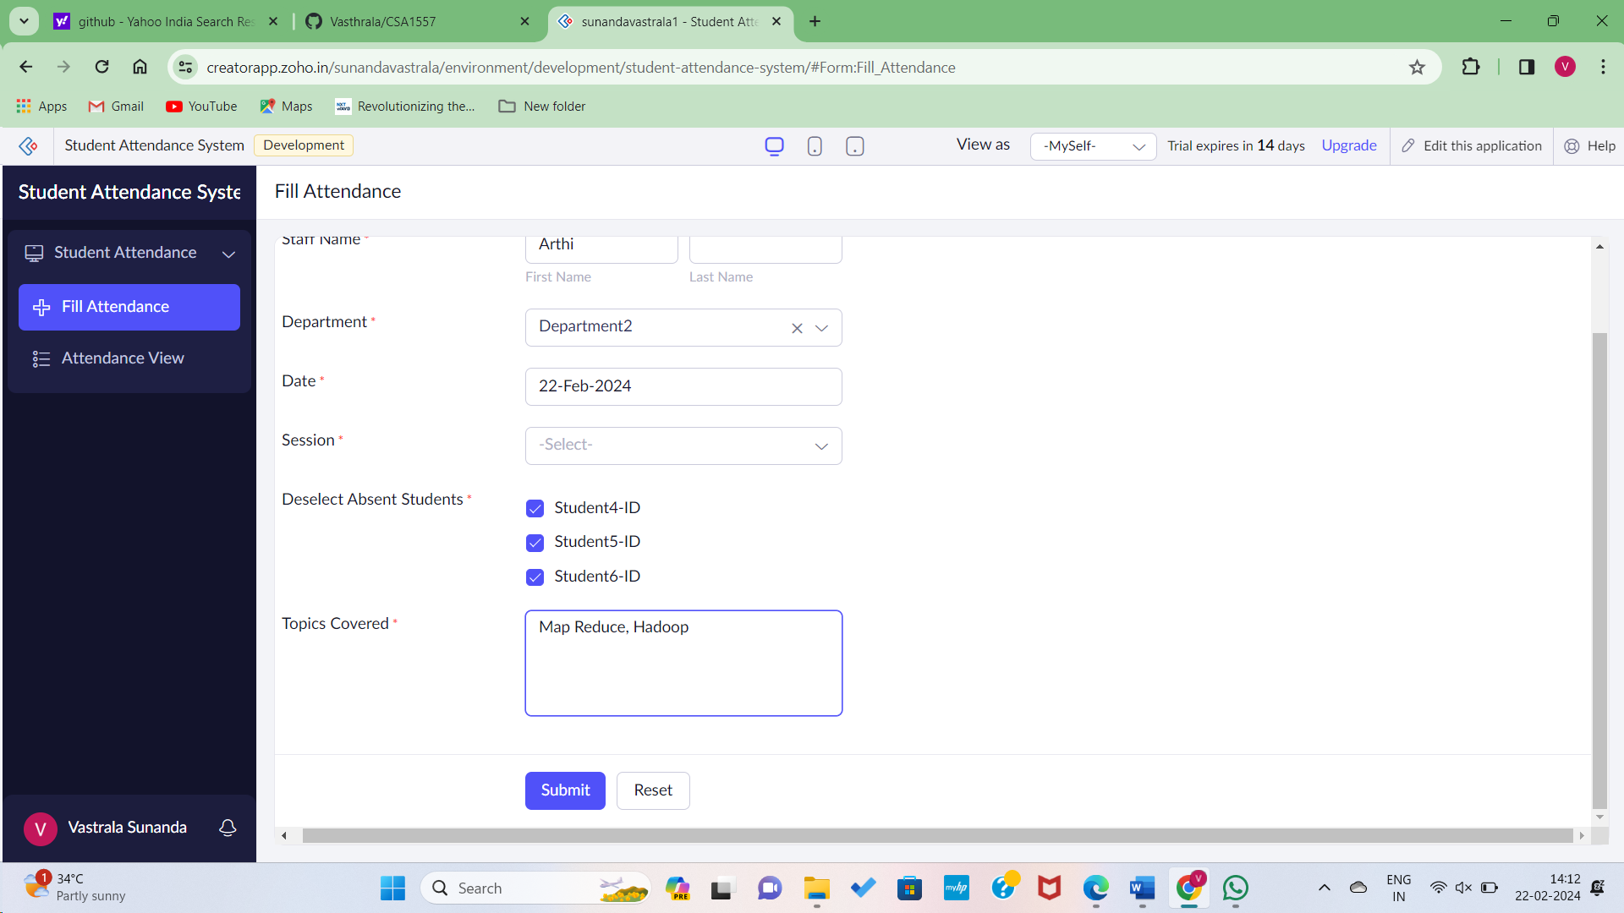

Step5: Filled Data in the application form viewing Student attendance system report.

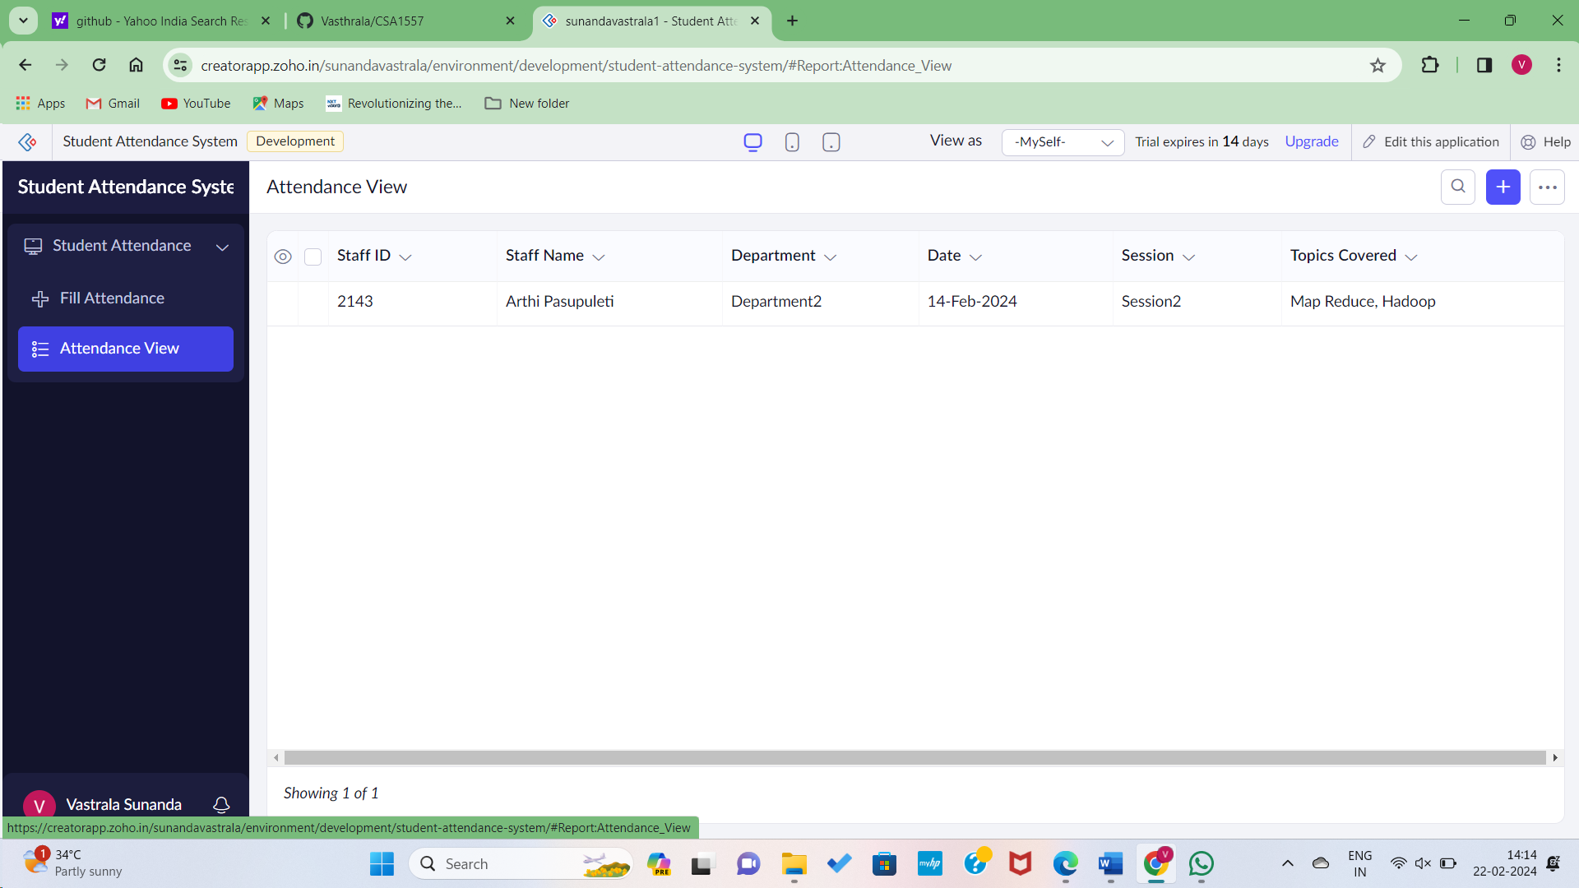

Step6: Creating Application form to fillup details including Staff and Initial Hours and Total Hours.

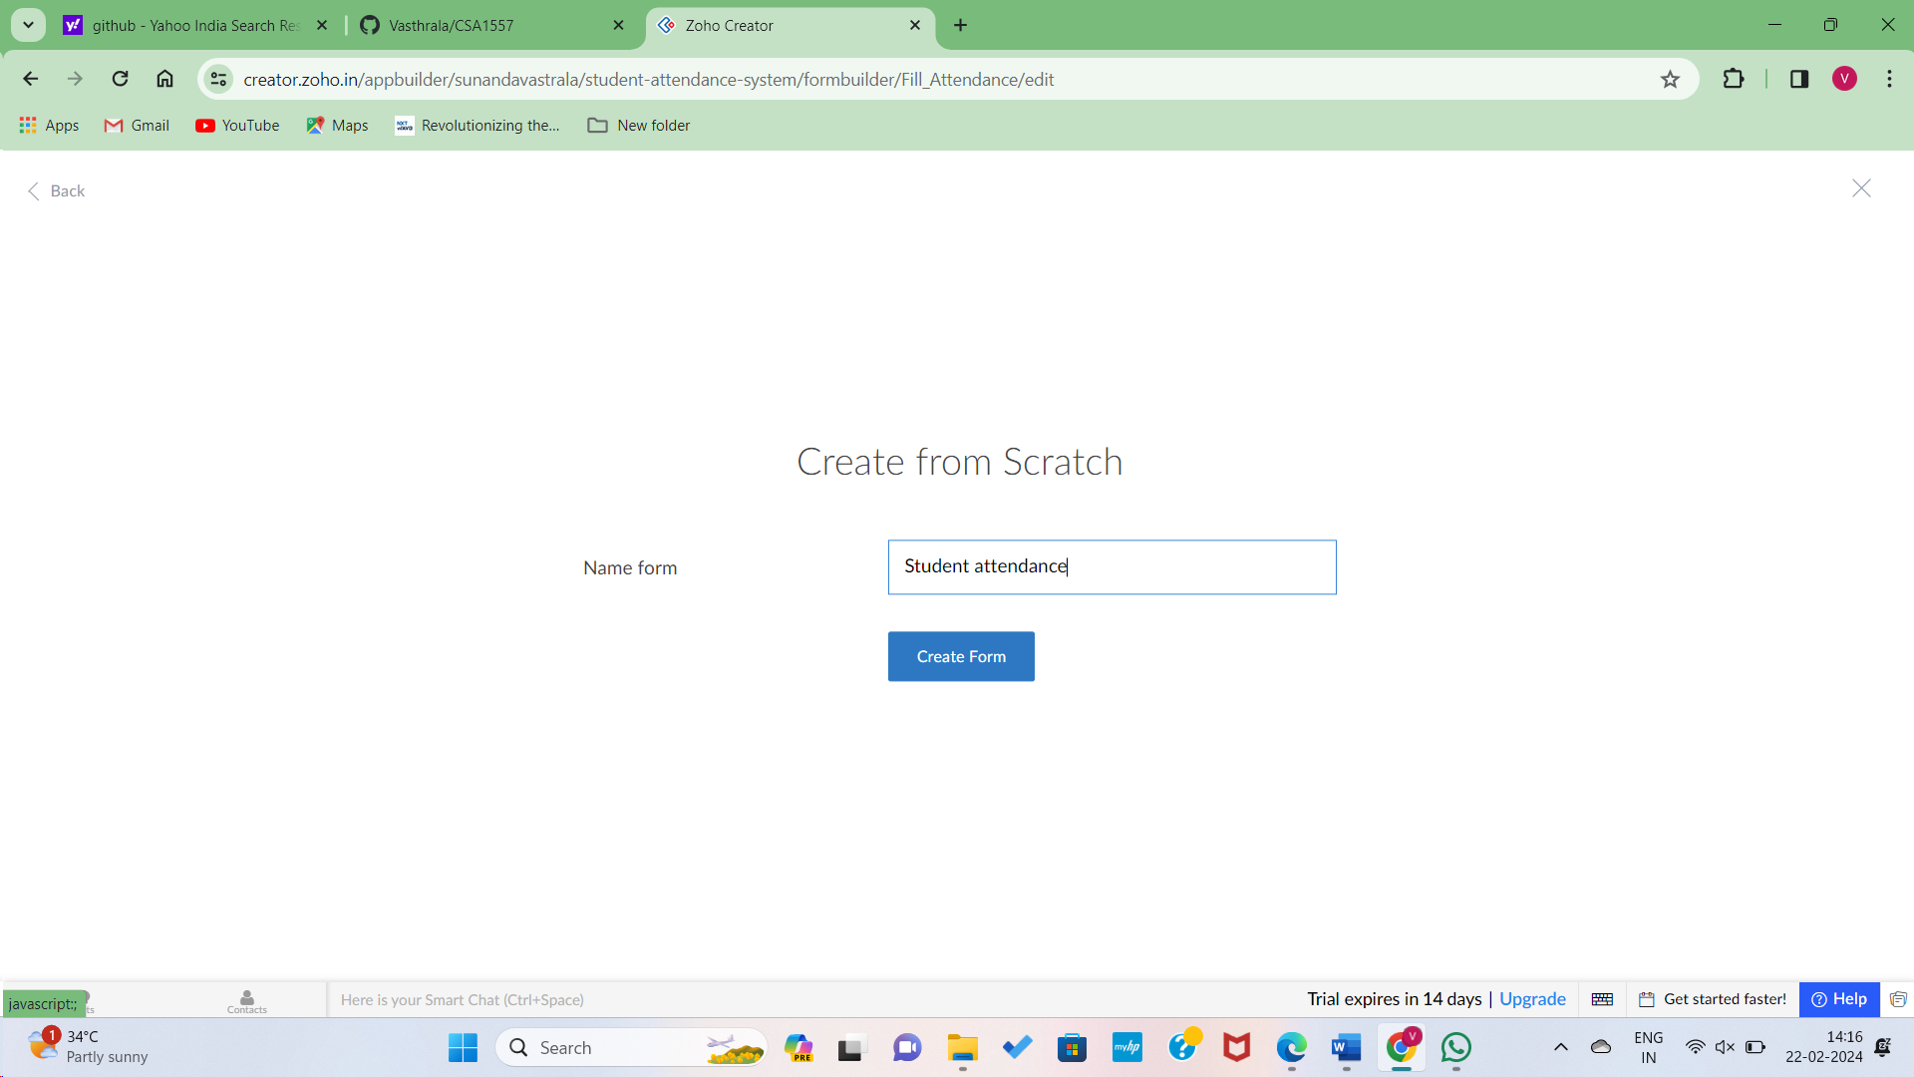

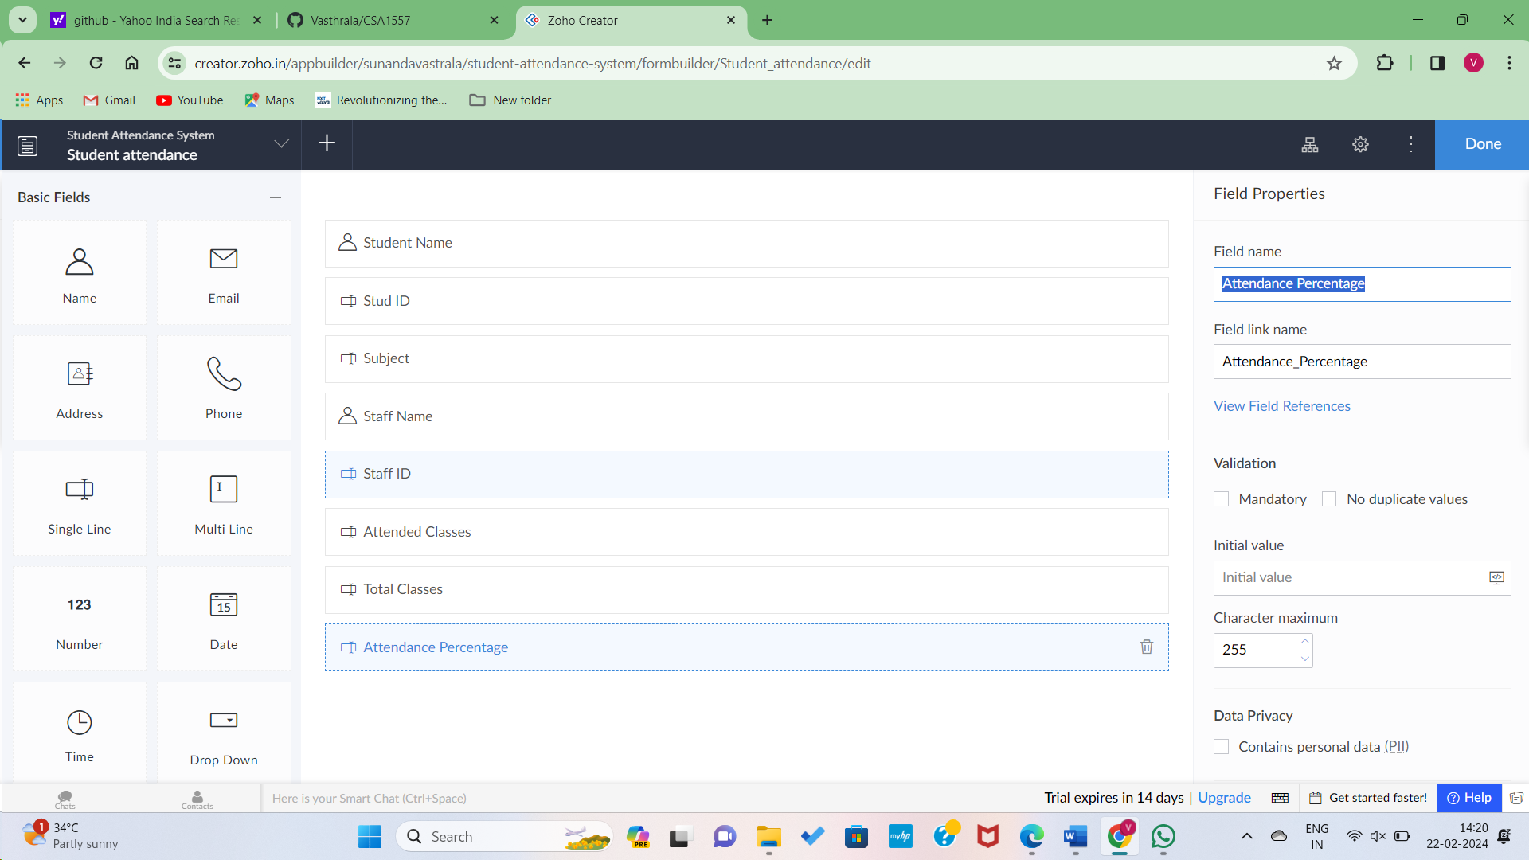

Step6: Data Enetring to Submit and Viewing in Student Report.

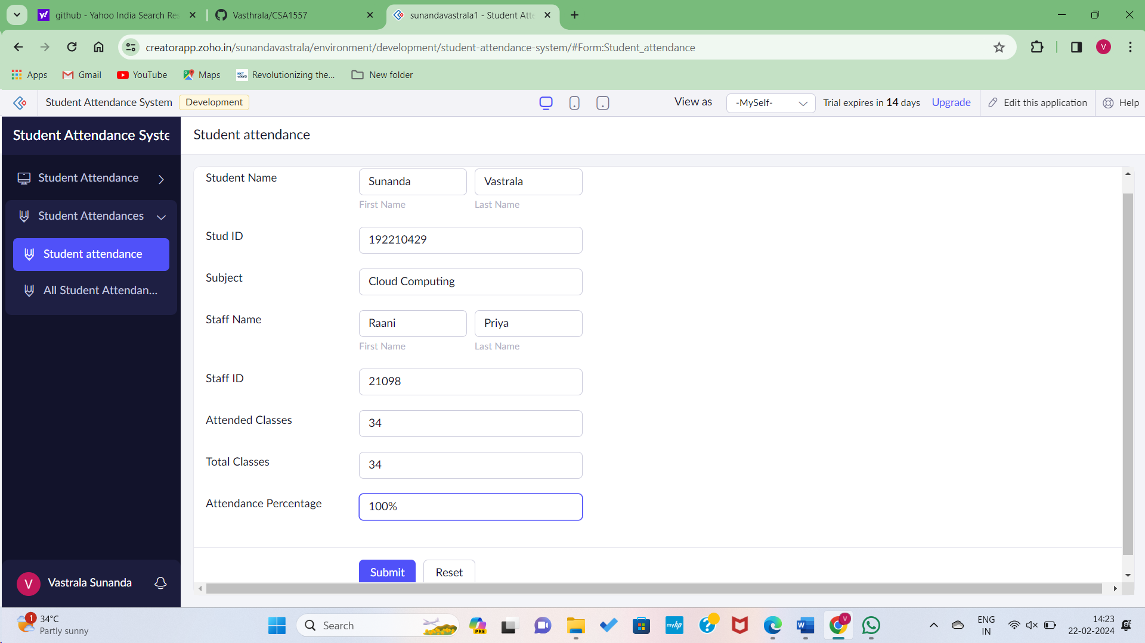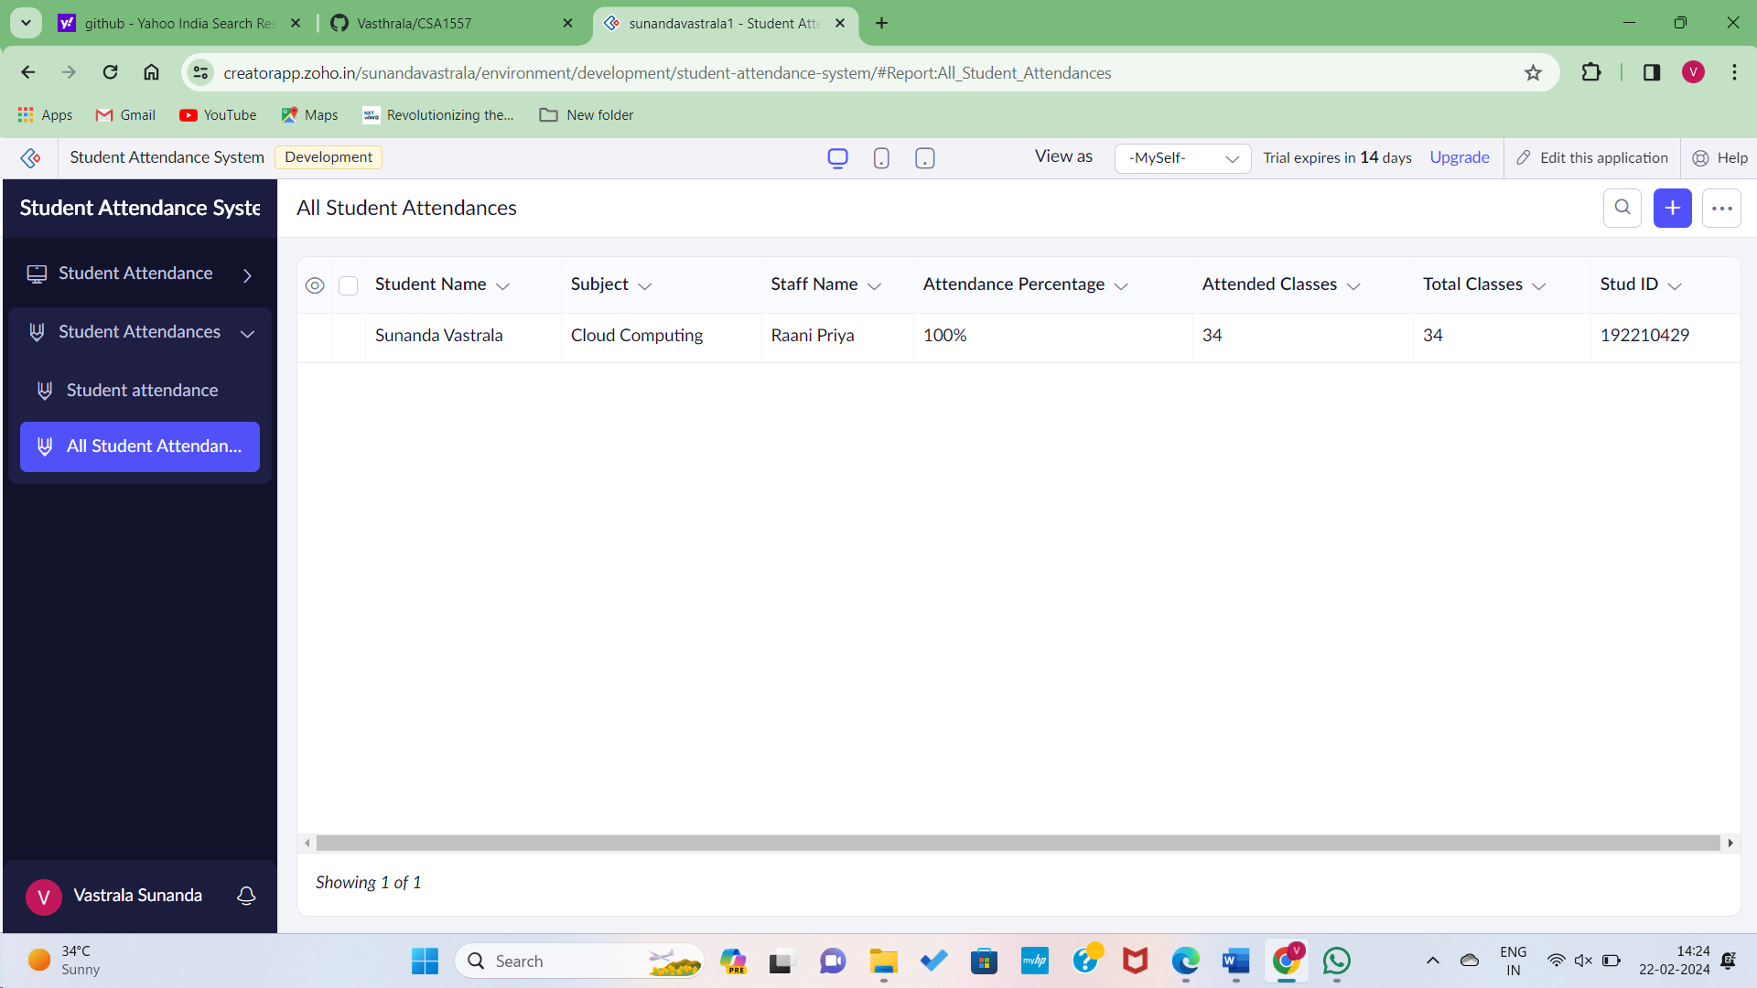

Step 7: Implementing the features for marking attendance, submitting OD(Leave) request and updating grades.

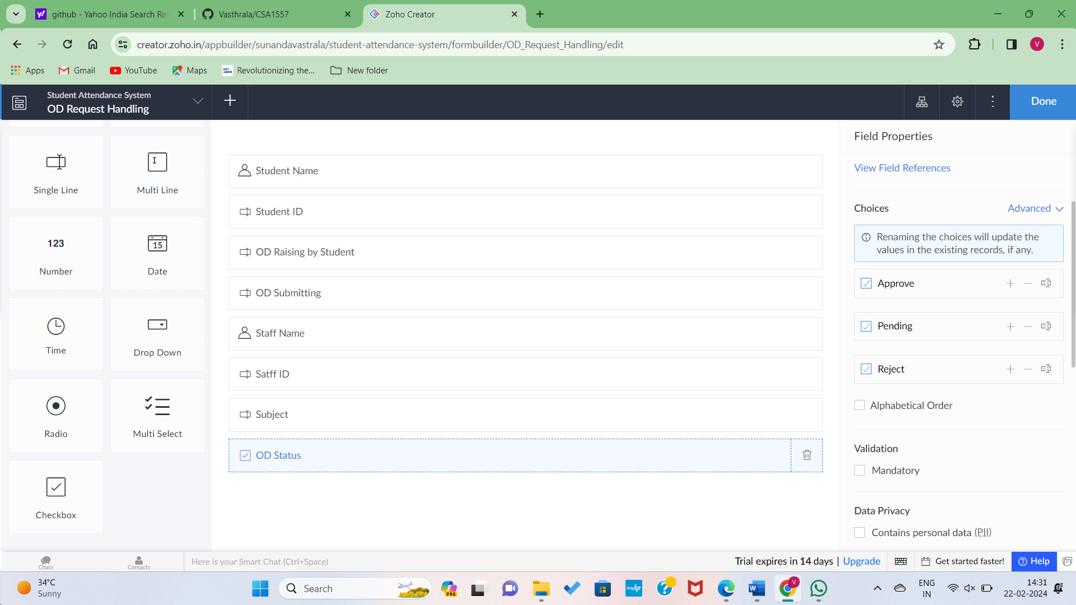

Step8: Implementing a workflow for approving or denying OD Requests.

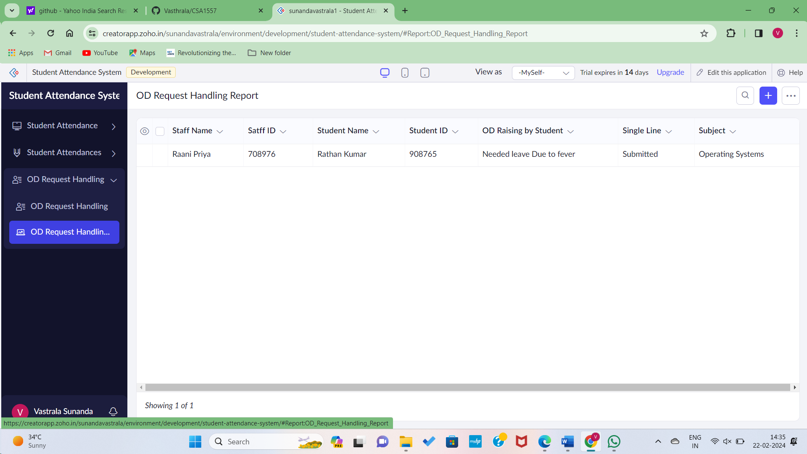

Hence the Forms Created for student attendance system, OD Requesting and grading systems..